Module Name: Login
Test Case ID: SD_TC_001
● Scenario ID: 1a
Scenario: Sign up with valid credentials
Test Steps: 1. Open orange HRM
2. Enter valid username & password
3. Click Login
Scareenshots:
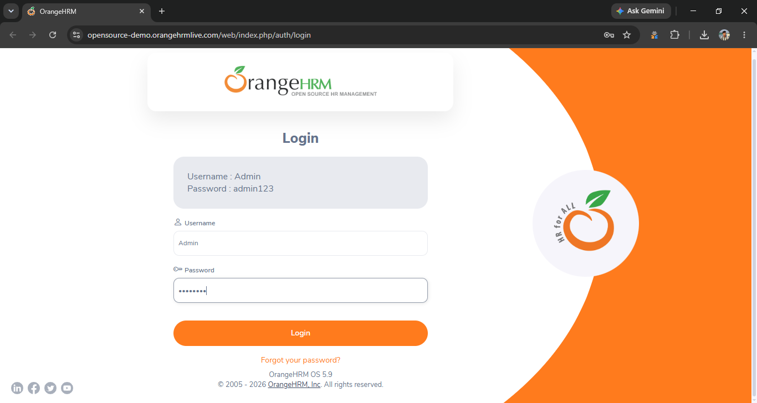
. scenario id 1b
login with wrong user name
test step
1 user name seth
2 password 123
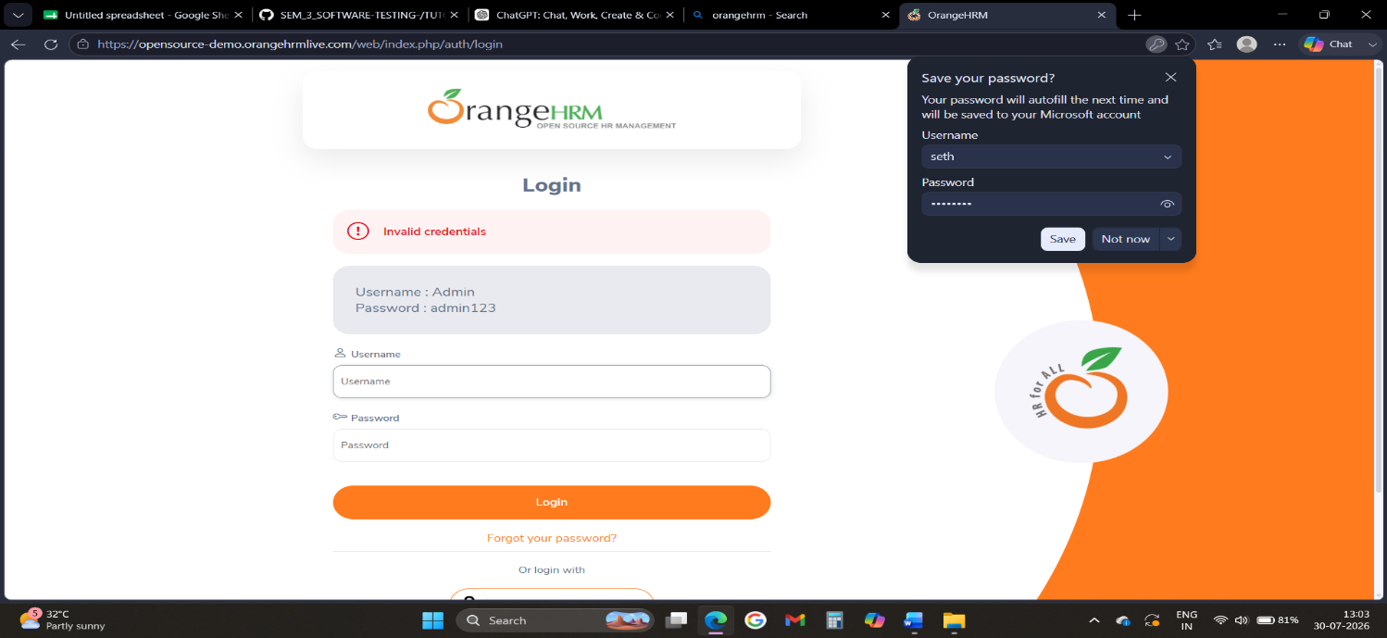
. scenario id:1c
Scenario: login with wrong password
Test step:
1. Ener valid user name
2. wrong password
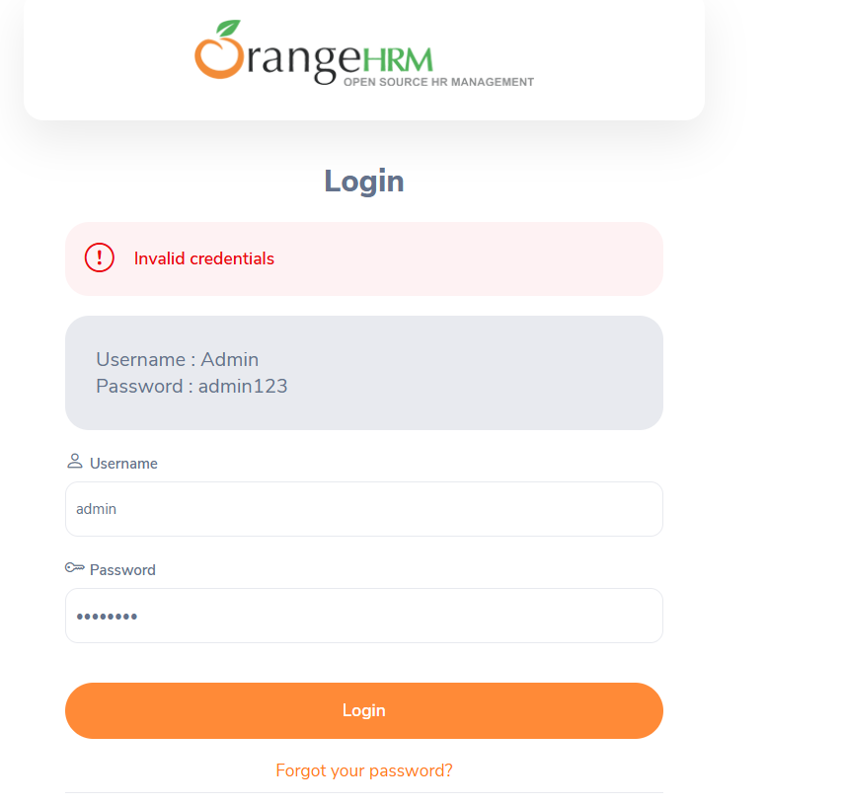
Scenario: id 2a
Scenario : search bar ( search wrong user name)
Test step:
1.enter wrong name ( seth raj)
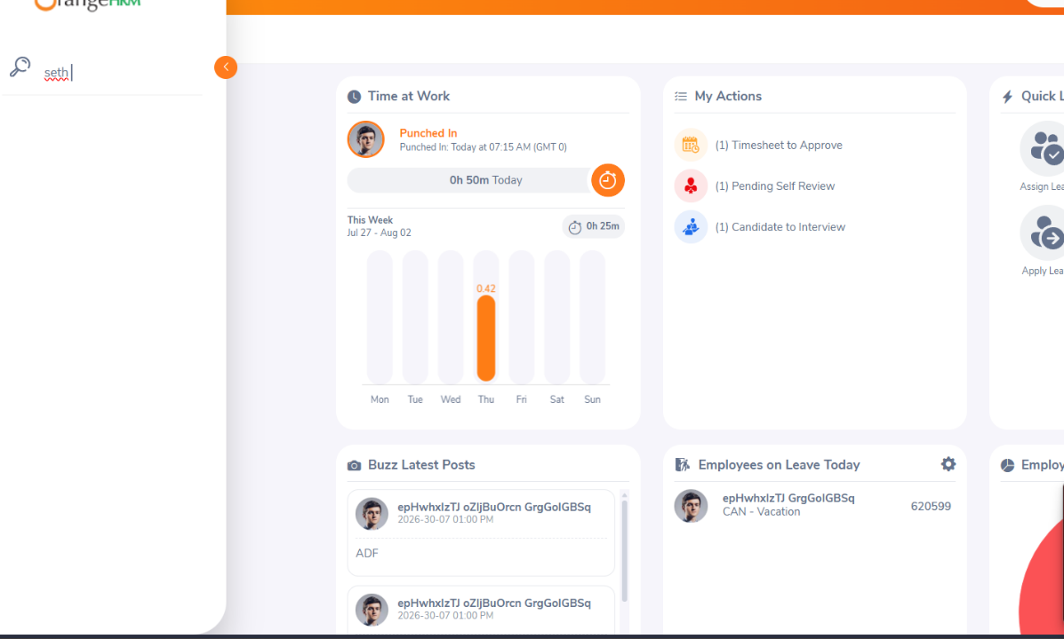
Scenario:2b
Scenario step:
1:search leave
2: search wrong date of leave
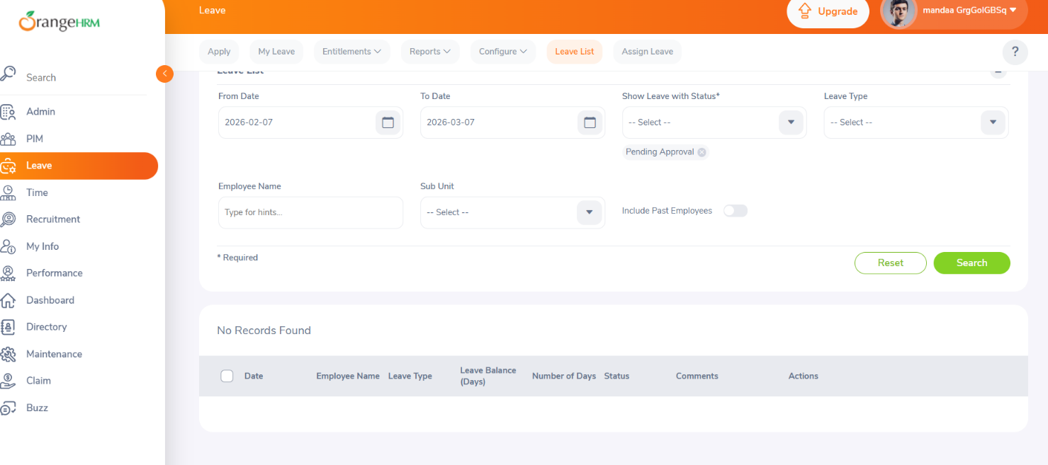
Scenario:2c
Scenario step :
- search leave
- search right date of leave

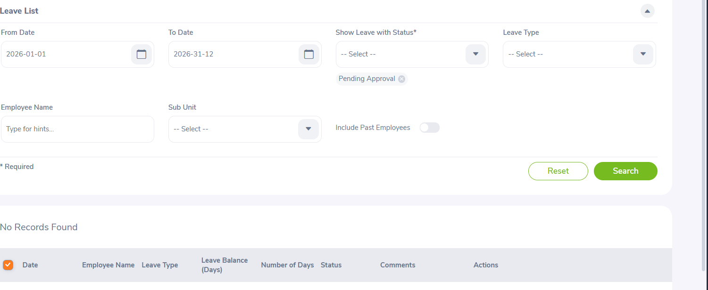

Scenario:2d
Scenario step:
- Rename employee's name

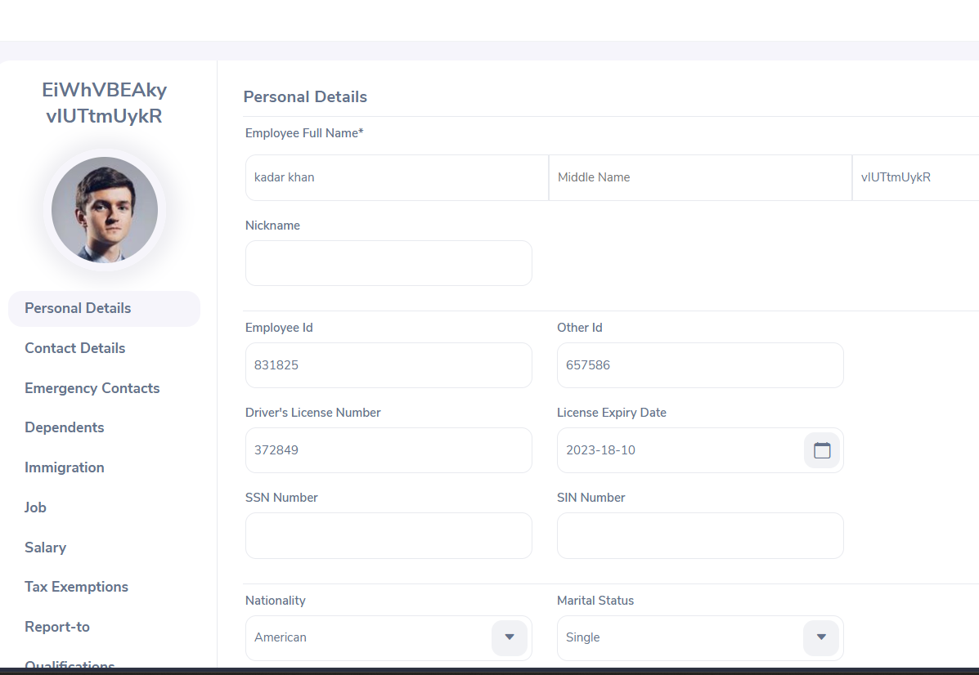

Scenario :2e
Scenario step
- change leave time
- 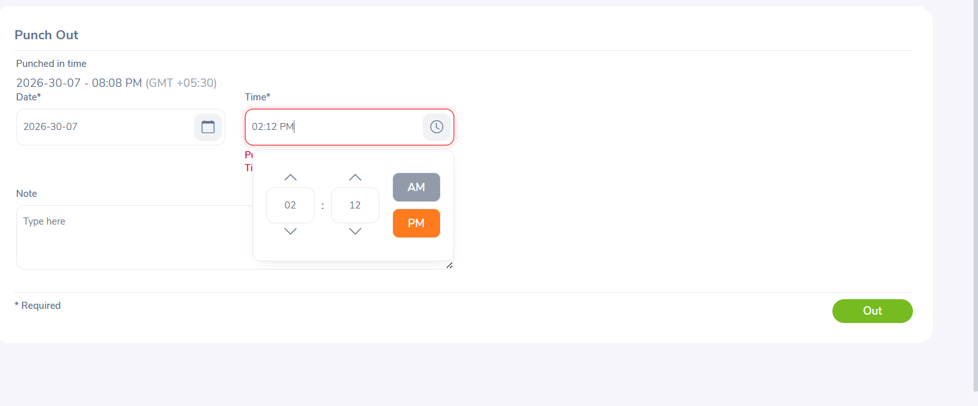

Scenario:3a
Scenario step:
1 serch bill transfer
(serch right info)
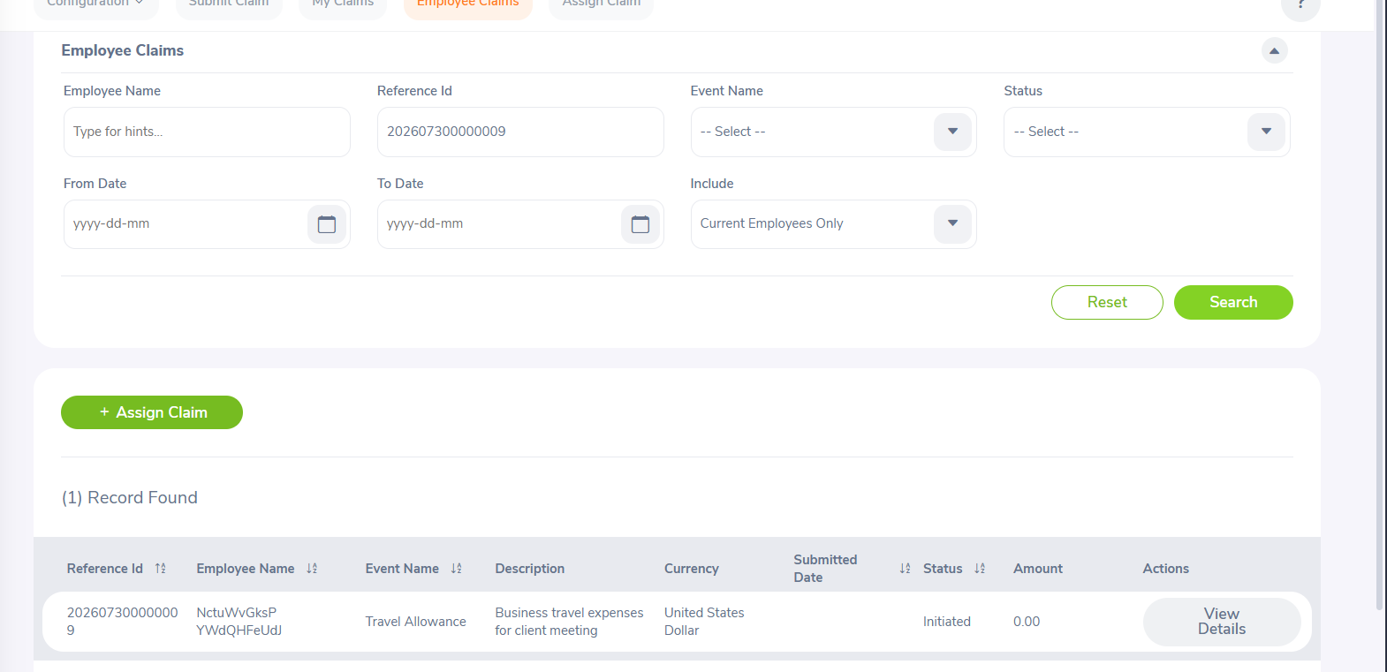
Scenario:3b
Scenario step:
1 serch bill transfer
(serch wrong info)

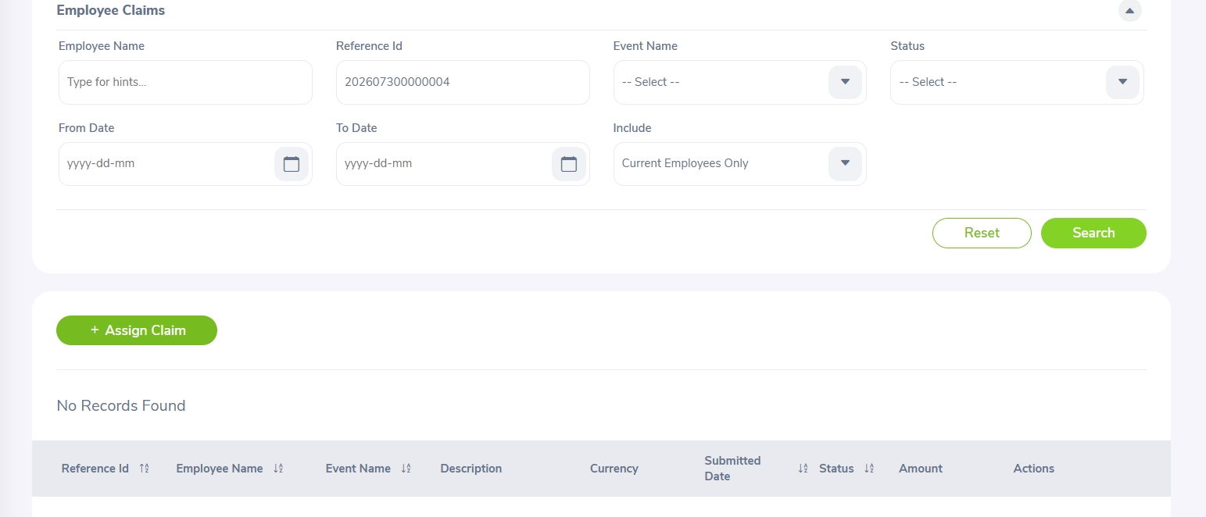
Scenario:3c
Scenario step:
1 edit transfer amount

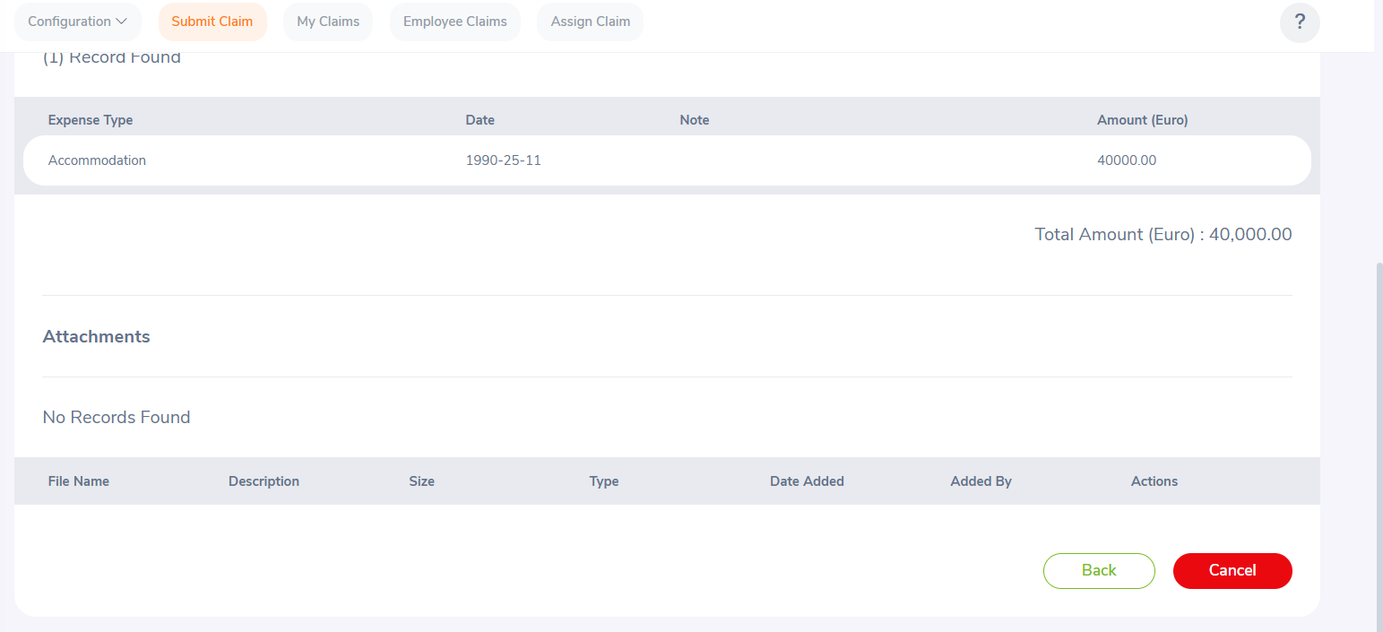
Scenario4a
Scenario step:
logout
